**THIS SCRAMBLE WILL BE COMPRISED OF FOUR-PERSON TEAMS:**

**Golfer #1:** Email Address: Cell Phone #:

◻ RiverEdge member ◻ Non-member

(PLEASE CHECK ONE)

**Golfer #2:** Email Address: Cell Phone #:

◻ RiverEdge member ◻ Non-member

(PLEASE CHECK ONE)

**Golfer #3:** Email Address: Cell Phone #:

◻ RiverEdge member ◻ Non-member

(PLEASE CHECK ONE)

**Golfer #4:** Email Address: Cell Phone #:

◻ RiverEdge member ◻ Non-member

(PLEASE CHECK ONE)

FILL OUT THE FORM ABOVE AND REVERSE SIDE FOR PAYMENT INFO

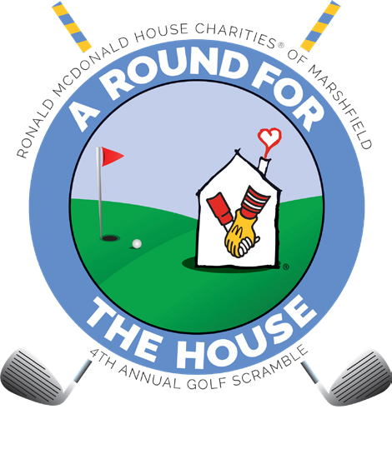KEEP THIS PORTION FOR YOUR REFERENCE

# Please complete, detach and send with

*checks made payable to RMHC of Marshfield.*

**Return to:**

# Ronald McDonald House Charities of Marshfield 803 W North Street

Marshfield, WI 54449

**Questions? Call 715.387.5899**

FRID A Y, A UGUS T 20 , 2021



**A ROUND FOR THE HOUSE GOLF SCRAMBLE**

to benefit Ronald McDonald House of Marshfield

Visit our website for more details **rmhc-marshfield.org**

FRIDAY, September 13, 2024

RIVEREDGE GOLF C OURSE MARSHFIELD, WISC ONSIN

**Marshﬁeld**

**Non-member Golfer: $75 each** Total Non-member Golfer $

**RiverEdge Member Golfer: $45 each** Total Member Golfer $

Golfer Total Enclosed $

Payment is being submitted by: ◻ Check # ◻ Credit Card

Name: Address: City State Zip

◻ **VISA** ◻ **MasterCard** ◻ **Discover** ◻ **American Express**

Account Number: Exp. Date:

CID/CW#

Signature

For questions or information about this payment, the best way to reach me is: Phone #

Email

